Lesson 5.3

3.Setting up the list of data

Add Affirmation strings

Create a new package

Create the Affirmation data class

Create a class to be a data source

[Optional] Display the size of the Affirmations list in a TextView

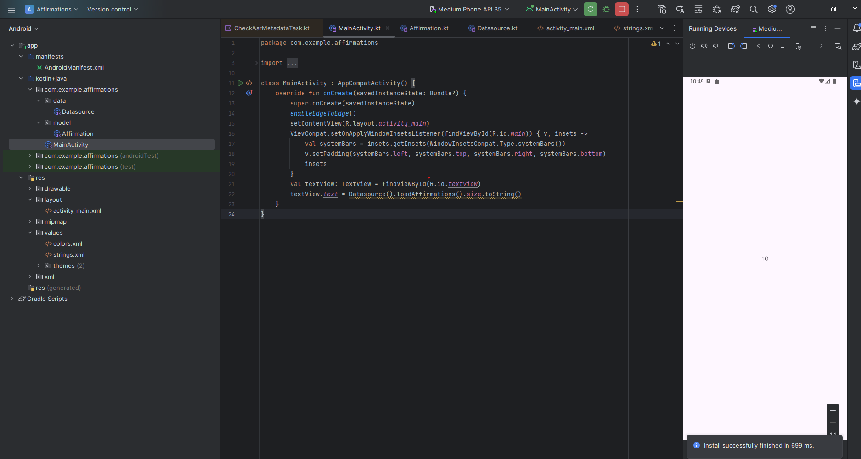

4. Adding a RecyclerView to your app